Experiment No. : 5

Title: Floyd-Warshall Algorithm using Dynamic
programming approach

Batch: B3 Roll No.: 16010422230 Experiment No.: 05

Aim: To Implement All pair shortest path Floyd-Warshall Algorithm using Dynamic programming approach and analyse its time Complexity.

Algorithm of Floyd-Warshall Algorithm:
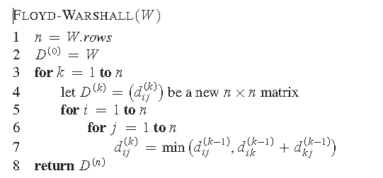

Constructing Shortest Path:
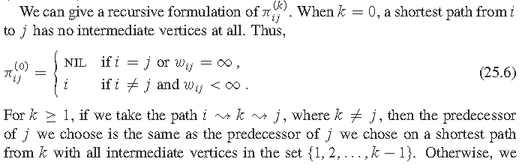
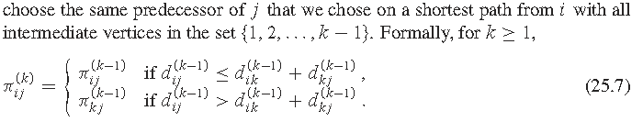

Working of Floyd-Warshall Algorithm:

Problem Statement
Find Shortest Path for each source to all destinations using Floyd-Warshall Algorithm for the following graph
Solution

CODE:

def floyd_warshall(graph):
n = len(graph)
dist = [[float('inf')] * n for _ in range(n)]

for i in range(n):
dist[i][i] = 0
for j in range(n):
if graph[i][j] != 0:
dist[i][j] = graph[i][j]

for k in range(n):
for i in range(n):
for j in range(n):
if dist[i][k] + dist[k][j] < dist[i][j]:
dist[i][j] = dist[i][k] + dist[k][j]

return dist

def print_shortest_paths(dist):
n = len(dist)
print("Shortest paths between all pairs of vertices:")
for i in range(n):
for j in range(n):
if dist[i][j] == float('inf'):
print(f"From vertex {chr(65+i)} to vertex {chr(65+j)}: No path")
else:
print(f"From vertex {chr(65+i)} to vertex {chr(65+j)}: {dist[i][j]}")

def take_user_input():
n = int(input("Enter the number of vertices in the graph: "))
graph = [[0] * n for _ in range(n)]

print("Enter the connections between vertices (e.g., A B 5 for connection from A to B with weight 5):")
print("Enter 'done' to finish input.")
while True:
connection = input().split()
if connection[0] == 'done':
break
vertex1, vertex2, weight = connection[0], connection[1], int(connection[2])
graph[ord(vertex1) - ord('A')][ord(vertex2) - ord('A')] = weight

return graph

graph = take_user_input()

shortest_paths = floyd_warshall(graph)

print_shortest_paths(shortest_paths)

Derivation of Floyd-Warshall Algorithm:

Time complexity Analysis

- Initialization:
  - Creating the adjacency matrix: O(V^2)
  - Initializing the distance matrix: O(V^2)
- Main Loop:
  - The algorithm consists of three nested loops.
  - For each vertex, the algorithm considers all other pairs of vertices to update the shortest path.
  - Each iteration updates the distance matrix for all pairs of vertices.
  - Since there are V vertices and the algorithm runs V times, the time complexity for this part is O(V^3).
Therefore, the overall time complexity of the Floyd-Warshall Algorithm is O(V^3), where V is the number of vertices in the graph.

Output(o) of Floyd-Warshall Algorithm:

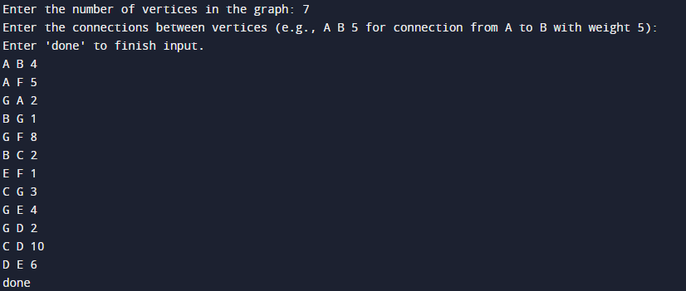

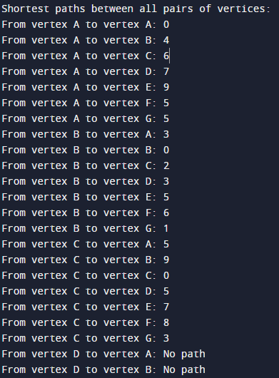
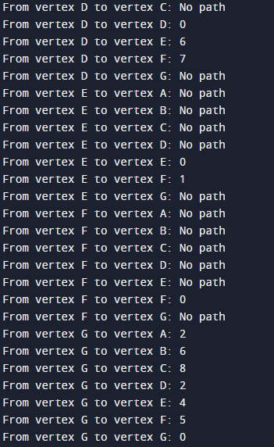

Post Lab Questions:- Explain dynamic programming approach for Floyd-Warshall algorithm and write the various applications of it.

The dynamic programming approach in the Floyd-Warshall algorithm involves solving the all-pairs shortest path problem by breaking it down into simpler subproblems, computing the shortest paths between all pairs of vertices iteratively, and storing the intermediate results. This algorithm is widely used in routing protocols, robotics, GIS, traffic management, game development, dependency resolution, and resource allocation due to its ability to efficiently find shortest paths between all pairs of vertices in a graph.

The Floyd-Warshall algorithm finds applications in various fields, including:
- Network Routing: Used in routing protocols to determine the shortest paths between all pairs of nodes in a network, facilitating efficient data transmission.
- Robotics: Employed for path planning algorithms in robotics to compute optimal paths for robots navigating in environments represented as graphs.
- Geographic Information Systems (GIS): Utilized to calculate distance matrices between all pairs of locations, aiding in route optimization, spatial analysis, and location-based services.
- Traffic Management: Applied to optimize traffic flow by determining the shortest paths between intersections or destinations, minimizing travel times and congestion.
- Game Development: Utilized in pathfinding algorithms for NPCs (non-player characters) or game objects to navigate game environments efficiently.

Conclusion: (Based on the observations):
In short, the Floyd-Warshall algorithm efficiently solves the all-pairs shortest path problem using dynamic programming. It finds applications in diverse areas such as network routing, robotics, GIS, traffic management, game development, dependency resolution, and resource allocation. Its versatility and ability to handle dense graphs make it a valuable tool for optimizing pathfinding and network traversal tasks in various domains.

Outcome:
CO2 - Implement Greedy and Dynamic Programming algorithms.

References:
- Richard E. Neapolitan, " Foundation of Algorithms ", 5th Edition 2016, Jones & Bartlett Students Edition
- Harsh Bhasin , " Algorithms : Design & Analysis", 1st Edition 2013, Oxford Higher education, India
- T.H. Coreman ,C.E. Leiserson,R.L. Rivest, and C. Stein, " Introduction to algorithms", 3rd Edition 2009, Prentice Hall India Publication
- Jon Kleinberg, Eva Tardos, " Algorithm Design", 10th Edition 2013, Pearson India Education Services Pvt. Ltd.

